**Purpose**: To recreate the topology and static routing table that was created in class.

**Topology**

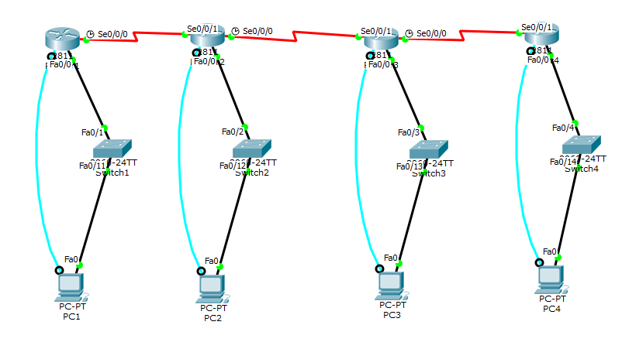

**Command Syntax**

|  |  |
| --- | --- |
| *Show IP Route* | Displays the current routing table for the selected router. |
| *IP Route … … …* | Sets a static route for the target network. *IP route network subnet mask gateway* |
| *IP Interface Brief* | Shows network connections, with their names shorten as possible, but still allowing for comprehension. |
| *Show Controllers* | Displays hardware related information, status, and other useful information for diagnosing issues and troubleshooting. |
| *RIP* | Dynamically assigns paths for routing into different networks. |

**Verification**

PC1 – Router1 – Router4 – PC4

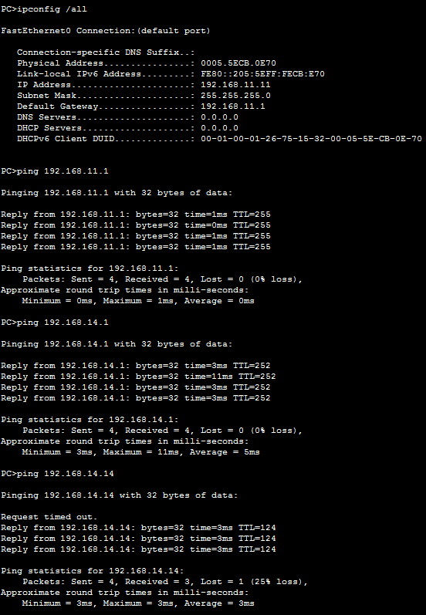

PC4 – Router4 – Router1 – PC1

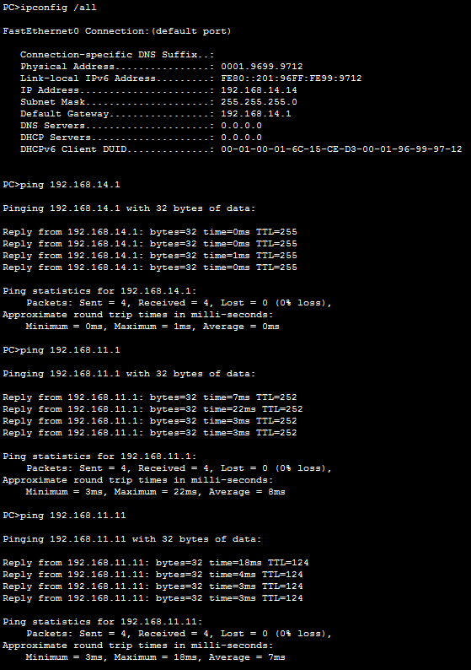

Router1

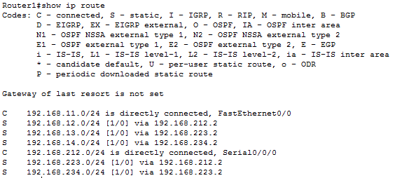

Router2

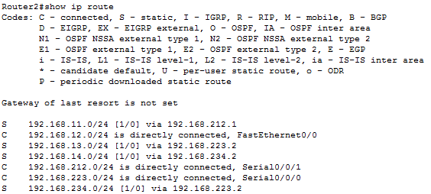

Router3

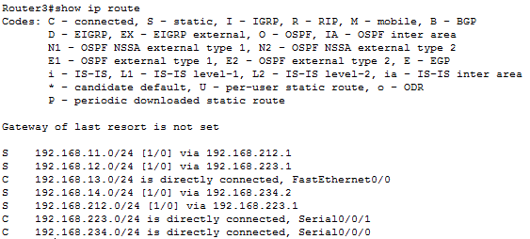

Router4

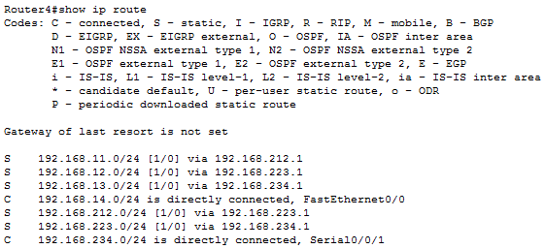

**Results/Outcome**

I rather enjoyed this lab, while it took a while for everything to be set up since I chose to do the lab through the console as much as possible for the sake of practice. Once I setup the topology from last week’s lab, since there was an error in the original setup, you could start setting up static routing. Static routing is best set up from one direction to another, this allows for constant checking and therefore the reduction of mistakes and any possible complications from something simply “slipping the mind”. In the end I was able to ping every other device on the network, from the selected device. I consider this a success.